# Environment Setup

## CICS definition

Raise request to define WOLA transaction and CICS program to be involved.

**Sample:**

MTGB.MEW.SRC.AFEWS.API(UMXEW2@L)



MTGB.MEW.SRC.AFEWS.API(UMXTRD@F)



CR used to defined this PPT and PCT : **CHG0001918050**

## JSON schema / Bind file creation and promotion

Develop copybooks for request and response message.

Stage in CMN to generate JSON schema and bind file, then promote the package.

**>> Sample copybooks:**



**>> Sample package:**

MX02000028

**>> Sample JSON schema:**



## Server.xml setup for URI using CMP

**Sample:**



**Request: WS48371019**

|  |  |  |  |  |  |  |  |  |  |  |  |  |  |  |  |  |  |  |  |  |
| --- | --- | --- | --- | --- | --- | --- | --- | --- | --- | --- | --- | --- | --- | --- | --- | --- | --- | --- | --- | --- |
| [Mainframe BI WAS Request](https://cmp.nj.ssmb.com/marketplace/control/product/~productId=44764_144905_GLOBAL) Qty: 1   |  |  | | --- | --- | | Configuration Options | | | **Please Select The Region This Request Relates To:** | LATAM | | **Please select your Business Entity:** | GCG | | **Please Select The Environment For This Request:** | Non-Production | | **Please select the System LPARs:** | MT01, MT02 | | **Please select one of the following WebSphere Products:** | Other WebSphere Related Products | | **Please Select action of this request:** | Add | | **Planned NON Production Implementation Date:** | 2017-04-25 | | **Please Describe in details Application, Product and Resource Requirements:** | This is for the server.xml setup request for the service name as per the attached doc. | | **Please upload any further information:** | [zOSC55 zOS Connect Non-Prod Def Request Form GLOBAL-AFEWS-SIT-blkOvcDtch.docx](https://cmp.nj.ssmb.com/marketplace/services/public/getResource.jsp?dataResourceId=7ZVdty7Sh7MnDoOxk6yHcavpxZcbqE) | |

## Program development and promotion

Package : GBCX003019

# Sanity check

## Prepare Sample Payload

**Sample:**



## Logon thru service URL

**Sample:**

<https://mt01vip1.mt01.mex.nsroot.net:10443/zosConnect/services>

## Test the API via tools like Advanced Rest Client.

**Sample:**

<https://mt01vip1.mt01.mex.nsroot.net:10443/v1/card/afews/blkOvcAtch>

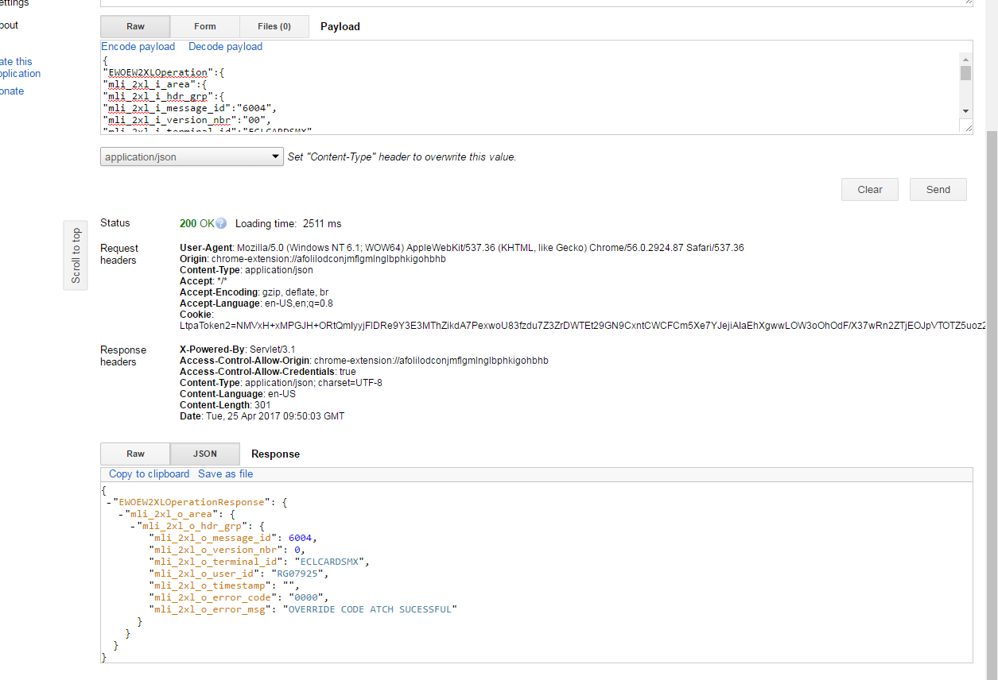

After attached Override code via Payload :

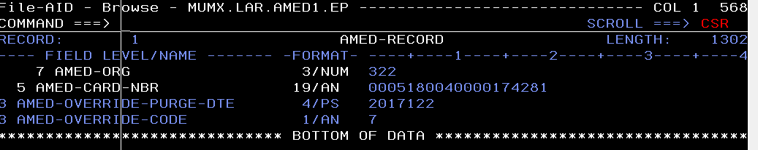

Transaction got declined due to AFEWS override code - 7 :

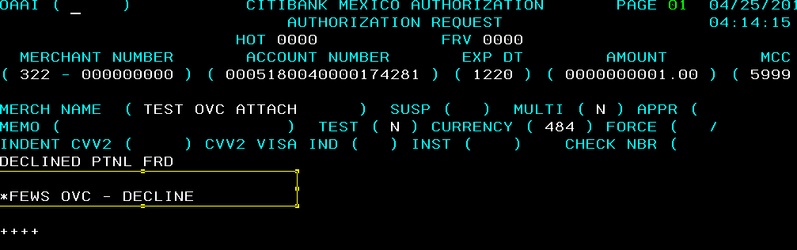

Detach override code via Payload :

Request :

{

"EWOEW2XMOperation":{

"mli_2xm_i_area":{

"mli_2xm_i_hdr_grp":{

"mli_2xm_i_message_id":"6004",

"mli_2xm_i_version_nbr":"00",

"mli_2xm_i_terminal_id":"ECLCARDSMX",

"mli_2xm_i_user_id":"RG07925",

"mli_2xm_i_timestamp":"2017-04-25-15.14.20.142014",

"mli_2xm_i_org":"000",

"mli_2xm_i_card_nbr":"0005180040000174281"

}}}}

Response :

{

"EWOEW2XMOperationResponse":

{

"mli_2xm_o_area":

{

"mli_2xm_o_hdr_grp":

{

"mli_2xm_o_message_id": 6004,

"mli_2xm_o_version_nbr": 0,

"mli_2xm_o_terminal_id": "ECLCARDSMX",

"mli_2xm_o_user_id": "RG07925",

"mli_2xm_o_timestamp": "",

"mli_2xm_o_error_code": "0000",

"mli_2xm_o_resp_msg": "OVERRIDE CODE DTCH SUCESSFUL"

}

**-**

}

**-**

}

**-**

}

**After Detach :**

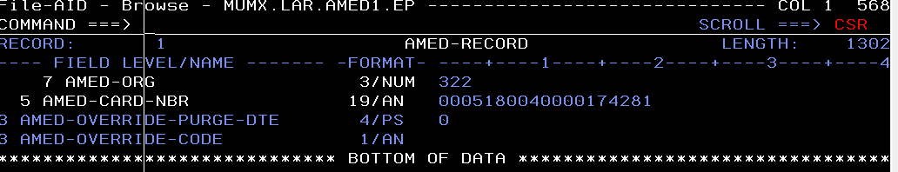

Transaction got approved :

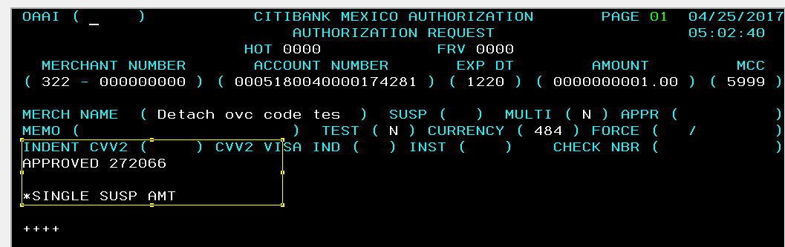

Override Code Attach via Payload :

{

"EWOEW2XLOperation":{

"mli_2xl_i_area":{

"mli_2xl_i_hdr_grp":{

"mli_2xl_i_message_id":"6004",

"mli_2xl_i_version_nbr":"00",

"mli_2xl_i_terminal_id":"ECLCARDSMX",

"mli_2xl_i_user_id":"RG07925",

"mli_2xl_i_timestamp":"2017-04-25-15.14.20.142014",

"mli_2xl_i_org":"000",

"mli_2xl_i_card_nbr":"0005449250000005891",

"mli_2xl_i_ovc_cd":"8",

"mli_2xl_i_ovc_pur_days":"10"

}

}

}

}

After override code attached : Inquiry for Ovc code :

Request :

{

"EWOEW2XLOperation":{

"mli_2xl_i_area":{

"mli_2xl_i_hdr_grp":{

"mli_2xl_i_message_id":"6004",

"mli_2xl_i_version_nbr":"00",

"mli_2xl_i_terminal_id":"ECLCARDSMX",

"mli_2xl_i_user_id":"RG07925",

"mli_2xl_i_timestamp":"2017-04-25-15.14.20.142014",

"mli_2xl_i_org":"000",

"mli_2xl_i_card_nbr":"0005449250000005891",

"mli_2xl_i_ovc_cd":"0",

"mli_2xl_i_ovc_pur_days":"0"

}

}

}

}

Response : Highlighted value we need to display as override code (8) and Expiry date (2017-05-05)

{

"EWOEW2XLOperationResponse":

{

"mli_2xl_o_area":

{

"mli_2xl_o_hdr_grp":

{

"mli_2xl_o_message_id": 6004,

"mli_2xl_o_version_nbr": 0,

"mli_2xl_o_terminal_id": "ECLCARDSMX",

"mli_2xl_o_user_id": "RG07925",

"mli_2xl_o_timestamp": "",

"mli_2xl_o_error_code": "0000",

"mli_2xl_o_error_msg": "**82017-05-05**OVERRIDE CODE ATCH SUCESSFUL"

}

-

}

-

}

-}